My website on Climate Change

Link to website: https://jamal01-bit.github.io/Web-Design-Assignment/index.html

Website Images
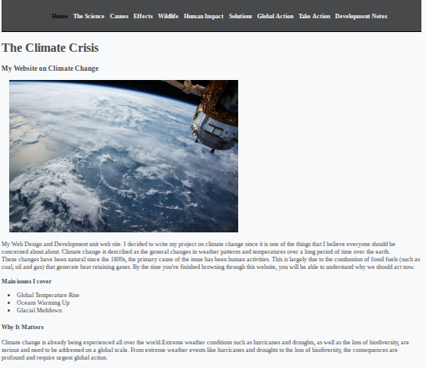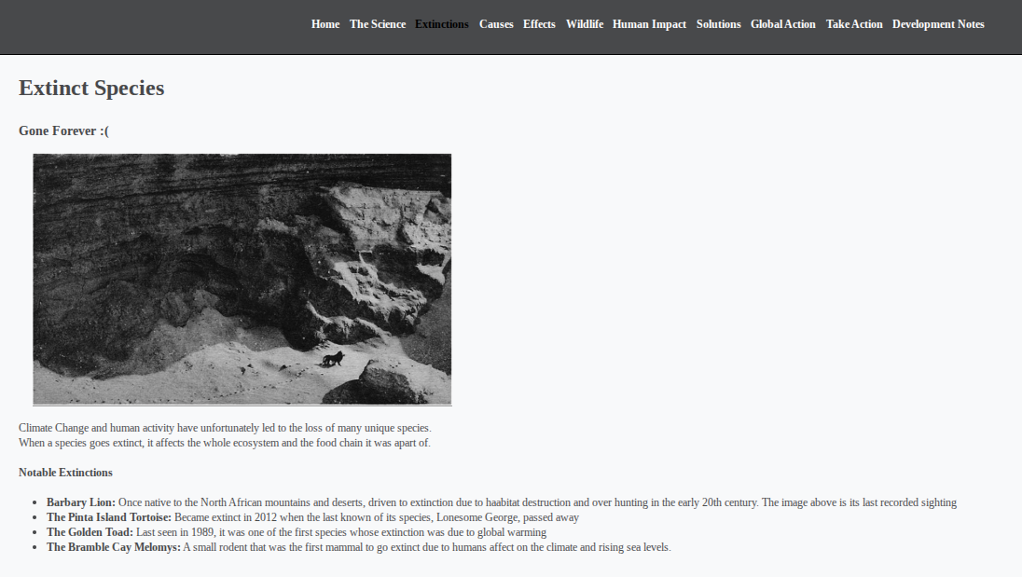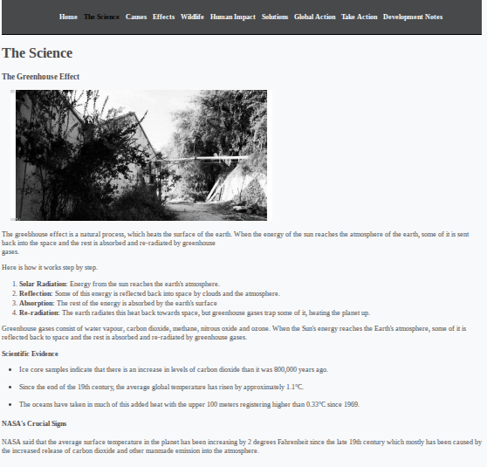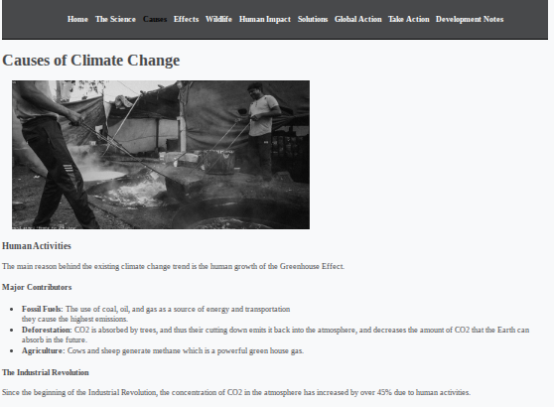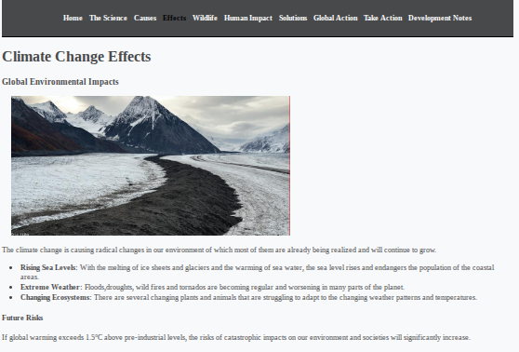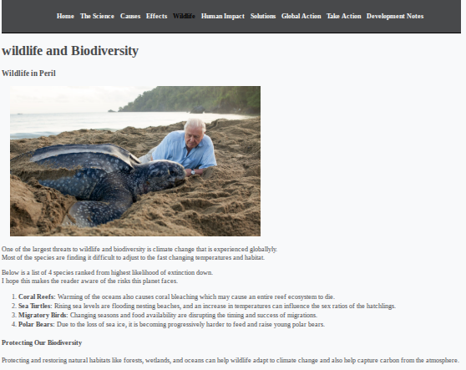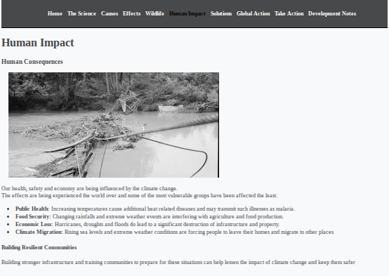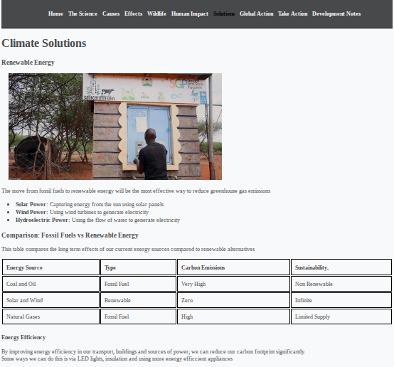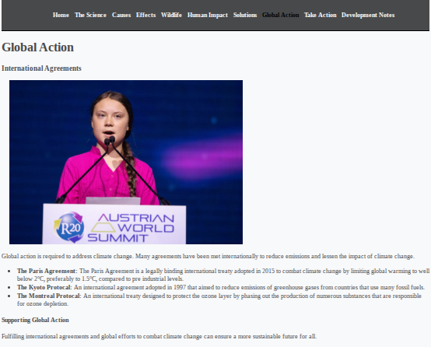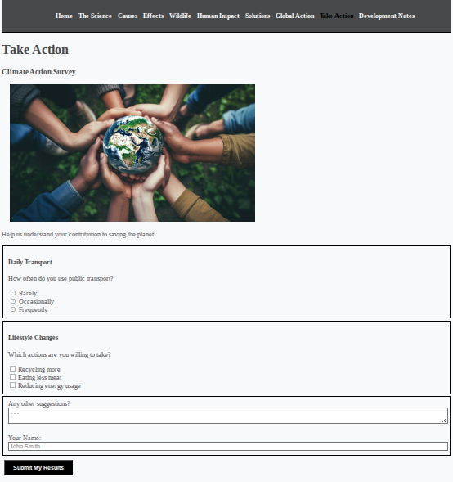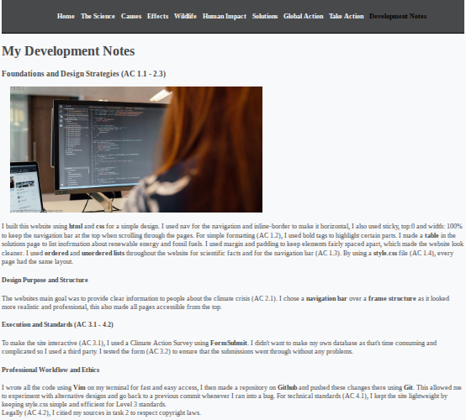

Project Design Documentation

I used the linux terminal and Vim editor to write all my code (AC 3.4). I also used Git to save my work and track any changes I made during the project (AC 3.4). This was a helpful technique because I could go back to previous versions of my website. Finally, I used Github Pages to host my website online so it is accessible to the public. (AC 3.4).

I used HTML5 (Hyper Text Markup Language 5) to build the skeleton and main content of each page (AC 1.1). I used tags like <html> and <body> to set the documents up correctly (AC 1.1). For the text, I used <h1> tag for main titles and <p> tag for any paragraphs (AC 1.1). I also used the <a href> tag for links to other pages in my website, in the navigation bar (AC 1.1). I used the <b> to make key terms bold, “text-align: centre” to centre the navigation bar, <ul>/<ol> for unordered/ordered lists respectively, <section> to separate different parts of each page and <br> to start a new line for some sentences.

I made a style.css file to control the structure and colouring of every page simultaneously (AC 1.4), this was done in CSS3 (Cascading Style Sheets 3). I used “inline-block” to make the navigation bar horizontal, “list-style-type:none” to remove the bullet points for each link (AC 1.3) and “position: sticky” to keep it viewable when users scroll down each page.

My first design idea was to use a frame structure where the menu stayed in a fixed box. However, I realised frames were outdated and take up a lot of space on the page, space that can instead be used for content, so I decided to use a navigation bar instead. This was a more practical choice as it makes it easier for the user to navigate to other pages, it also makes the website feel more practical (AC 2.3).

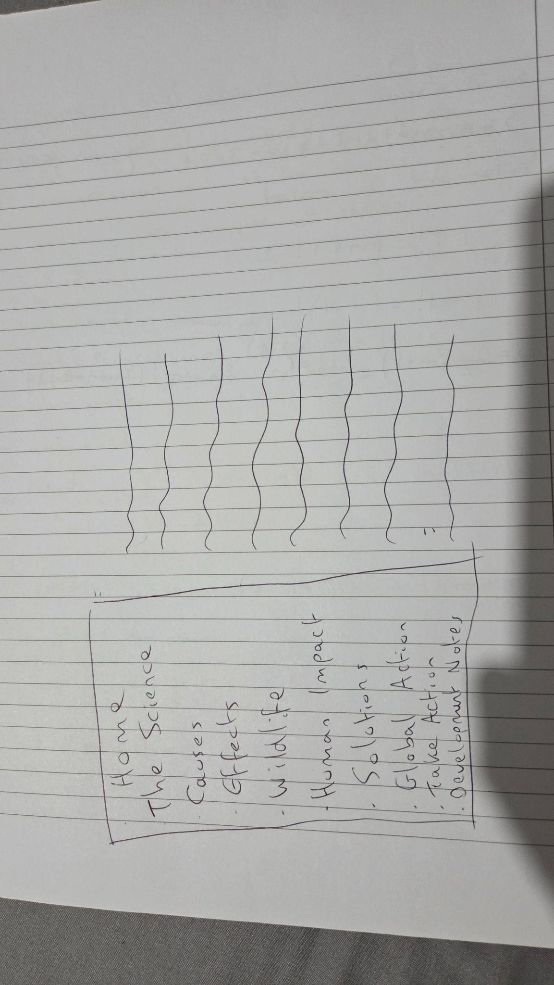

I reviewed and tested every navigation link to ensure they loaded the correct pages (AC 3.2). I improved the form because it was showing a 404 error whenever I tried submitting a response (AC 3.3). I removed the CAPTCHA check on the form as it was inconvenient whenever the user submitted a response for a simple survey (AC 3.3). Lastly, I improved the navigation bar width so that it covers the whole top of the screen (AC 3.3).
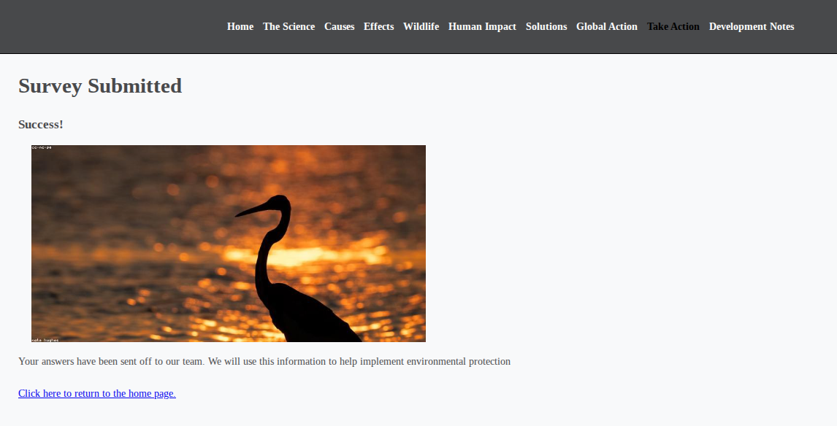
Evidence of pages working (form being submitted and sent to database)

My Development Notes

The main goal of my website is to give people clear and reliable information about the Climate Crisis (AC 2.1). I decided to focus on this topic as it’s an urgent issue that requires immediate global action. It affects every living creature on Earth and has already made some species extinct (AC 2.1). I don’t have a specific target audience as climate change is a universal threat, this website is just for people who want to learn more about global warming and what we can do to help (AC 2.1).

To meet the requirements for my website, I chose a navigation bar at the top of each page. This ensured that the user could go to any page the same way they could from any website and that any of the 11 pages were easily accessible (AC 2.1). Keeping the layout the same on every page makes it easier for people to focus on the information instead of how to navigate through the website.

By adding a survey, this gave the user an educational and engaging experience that would challenge their own carbon footprint and contributions towards the climate (AC 2.1). I wanted this to be interactive so that users would actually think about their own carbon footprint rather than just reading through a bunch of text, making the learning process feel more personal and impactful for the user.

I considered the technical factors that influence the performance and speed of my website (AC 4.1), so I used Vim editor as it’s fast and lightweight. I deployed the website to GitHub Pages for fast and accessible servers, which helps the website load faster for any user who visits. One major problem I ran into when doing this, was that I was unaware of the importance of having a page named “index.html”. Originally, my home page was named “home.html”, this caused the public domain to load my ReadMe file on my public repository instead. So I changed its name to index.html and this resolved the issue.

Building my own database is complicated, unnecessary and time consuming so I used FormSubmit to save responses and connected it to my personal email address to view any of them after submission. This kept the backend simple while still ensuring that the survey functioned properly.

A huge priority of mine was security and legal safety (AC 4.2). Since my website includes a survey, I had to think about how to protect user’s information such as their names and suggestions (AC 4.2), so I chose FormSubmit as it uses encryption on every submission. This means that any data sent off would be scrambled, protecting user’s data from hackers trying to steal information. I also made sure to only ask for basic information to keep the survey private.

Legally, I followed the copyright laws by using references and images from public domains and cited my sources below. This is also an ethical choice as it gives credit to the scientists who contributed to the research I used. Building this website not only made me more aware of my environment and how I can reduce my carbon footprint, but it also improved my programming. It pushed me to learn new skills such as Github Pages deployment, some Vim tricks and basic web design. I used w3schools and youtube tutorials to learn key parts of my website, such as the navigation bar and how to use FormSubmit.

Site Map
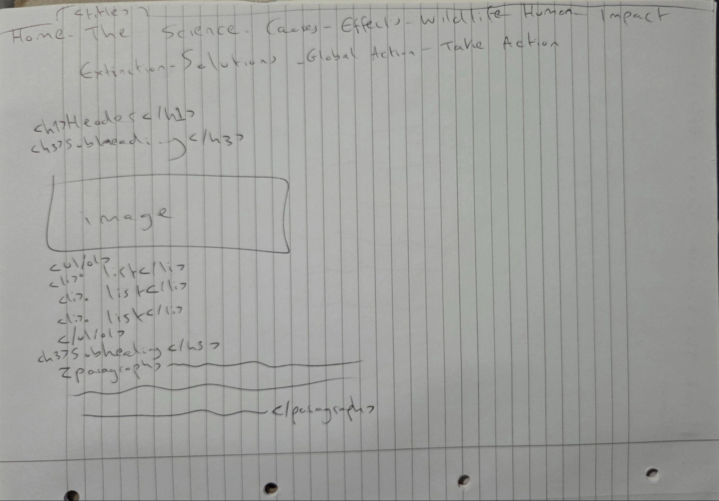

I used this site map above to help me plan the layout for most of my pages. This was helpful as it allowed me to design the website to have over 10 pages and what each page was going to be about. By planning my site this way, I ensured that it was practical for my target audience (AC 2.2). The user can easily jump from “Causes” to “Solutions” with just one click, making the website more efficient for learning about Climate Change (AC 2.2). This planning was necessary to make my website organised, professional and meet all assignment criteria.

Storyboarding

Before I started writing my code, I created a storyboard to plan out the visual layout of my website (AC 2.2). This was a vital step because it helped me design an 11 page website that met all the assignment criteria i.e. a working form survey. I planned for a consistent layout where the navigation bar would always stay at the top of the screen for easy access (AC 2.2). I also designed each page to have a white background and made the text dark grey so that it’s easier for people to read (AC 2.2). I planned to make the images directly above key scientific facts, making the information clearer (AC 2.2). For the interactive part of the site, I storyboarded a “Take Action” page to include a clean, simple form (AC 2.2). I planned in advance fieldsets that group questions into categories and surrounded the sections with a narrow black box. By storyboarding the structure of my website before beginning development, the final website came out consistent, user friendly and met all the criteria required for this assignment.

References

- NASA Global Climate Change - https://science.nasa.gov/climate-change - scientific facts and temperature data.

- Wikimedia Commons - main source for public domain images

- W3Schools HTML/CSS Tutorials - https://www.w3schools.com - main page for basic tutorials e.g. navigation bar

- Youtube/Coding Geek - https://www.youtube.com/watch?v=t11bU2djfLE - video on how to use FormSubmit

